Background
On April 10, 2017, the AESO and stakeholders participated in a consultation meeting to discuss (1) proposed changes to the ISO tariff’s terms and conditions; (2) cost responsibility for compliance with the Critical Infrastructure Protection (“CIP”) Alberta reliability standards; (3) results on the AESO’s point of delivery (“POD”) cost function database results and analysis; and (4) application process and next steps. Based on discussion at the meeting, the AESO invites written comments from stakeholders on the information presented. The meeting presentation is posted on the AESO website and can be accessed at www.aeso.ca by following the path: Rules, Standards and Tariff ► Stakeholder engagement ► 2018 ISO Tariff Application.
Please use the comment form below when submitting comments to the AESO on the 2018 ISO tariff consultation. Please ensure that your comments represent all interests within your stakeholder organization with respect to the consultation. Please provide comments or questions no later than May 2, 2017, to LaRhonda Papworth at larhonda.papworth@aeso.ca or 403-539-2555.
Consultation and Stakeholder Identification
Date of Request for Comments: | April 18, 2017
Period of Consultation: | November 15, 2016 – April 18, 2017
Comments From:
Date:
Contact:
Phone:
Email:

Stakeholder Comments on AESO Information
Stakeholder Comment
- ISO Tariff Terms and Conditions - Proposals
(Slides 6 – 36)
- Proceeding 20922 Closure Letter, March 29, 2017 (Slides 7-10):
- Issue 1: Legislative framework;
- Issue 2: Advanced system-related classification of radial transmission projects; and
- Issue 3: Load forecasting
Stakeholder Comments:

- Other Commission Decisions (Slides 11-12)
Stakeholder Comments:

- Principles for Load Customers (Slide 13):
- Provide a price signal;
- System transmission facilities are not built as the result of a connection(s) not proceeding; and
- Alignment with Commission’s issue list (Proceeding 20922).
Stakeholder Comments:

- System transmission facilities required for a load connection (Slides 14-19):
- Alternative selection for load connections (Slide 15);
- Market participant can wait for system or pay certainty charge/refund (Slide 16);
- “Refundable deposit” – What does it provide for the AESO? (Slide 17);
- Pros and cons – “refundable deposit” (Slide 18); and
- Options (Slide 19)
Stakeholder Comments:

- Alternative selection example 1 – “lowest overall costs” (Slides 20-23):
- Diagram - Alternative 1 is “lowest overall costs” (Slide 20);
- Diagram - Alternative 2 is “lowest overall costs” (Slide 21); and
- Diagrams - Other examples (not discussed) (Slides 22-23).
Stakeholder Comments:

- Changes to Sections 4, 5, 8 & 9: What are we proposing to add? (Slides 24-25):
  - New provisions that identify how the AESO will determine the preferred alternative;
  - Revised practices for system access (to replace the AESO’s “Practices for System Access Service”);
  - Defining and enforcing critical requirements for a SASR;
  - Identify when connection projects give us “sufficient certainty” that they will materialize;
  - New provisions around advancement costs and “accelerated construction” charges;
  - Differentiation between generation and load;
  - “Shared with system” cost provisions; and
  - Connections that are initially radial are 100% participant-related costs, to be “shared” if loop is closed.
Stakeholder Comments:

- Changes to Sections 4, 5, 8 & 9: What are proposing to revise/remove? (Slide 26):
- Remove any provisions that are duplicative of the legislation, rules, & reliability standards;
- Remove “contiguous” in Section 8 referring to a “contiguous” connection project;
- Remove provision referring to “planned to be looped” as system-related cost;
- Remove connection process references; and
- Revisit the “Good Electric Industry Practice” to reflect the AESO’s minimum requirements.
Stakeholder Comments:

- Other terms and conditions proposals (Slides 27-29):
- Section 1 – Applicability and interpretation of ISO Tariff;
  - Legal Review
  - Ensure no duplication of legislation, rules, or reliability standards
- Section 2 – Provision of and Limitations to System Access Service (may merge Sections 2 – 4);
  - Make distinction between load and generation
  - Add t-tap expectation of service
  - Remove outage provisions (covered in ISO rules)
- Section 3 – System Access Service Connection Requirements (may merge Sections 2-4);
  - Remove technical requirements (covered in ISO rules)
  - Move compliance requirements to Section 2
- Section 5 – Financial Obligations for Connection Projects;
  - Legal review
  - Ensure no duplication of other authoritative documents
- Section 6 – Metering;
  - Remove altogether, covered in ISO rules
- Section 7 – Provision of Information;
  - Review for duplication of authoritative documents and legislation
- Section 10 – Generating Unit Owners Contribution;
  - Add GUOC rates to the ISO tariff
- Section 11 – Ancillary Services;
  - No changes proposed
- Section 12 – Demand Opportunity Service;
  - No changes proposed
- Section 13 – Financial Security, Settlement and Payment Terms;
  - Duplication with ISO rules?
- Section 14 – Peak Metered Demand Waivers; and
  - No changes proposed
- Section 15 - Miscellaneous;
  - Confirm with legal review.
Stakeholder Comments:

- Workshop Slides (Slides 30-36):
  - Repeated from Slides 20-21 (Slides 31-32);
  - Example 1 background, area load, and area load forecasts (Slide 33);
  - Example 2 diagram and background (Slide 34); and
  - Example 2 area load and area load forecasts (Slide 35).
Stakeholder Comments:

- Terms and Conditions’ Changes – Next Steps (Slide 36):
- Allow stakeholders to review presentation and concepts, and provide feedback;
- Prepare application with revised terms and conditions.
Stakeholder Comments:

- POD Cost Function Database
(Slides 37 – 46)
- POD cost function database input into cost curves and options (Slides 38-39):
  - AESO was directed to “use ‘Greenfield and Update Excluding 0 MW’ until the matter can be thoroughly explored” (Slide 38);
  - AESO thoroughly exploring four options (Slide 39).
Stakeholder Comments:

- Comparison of options to existing (2014 ISO Tariff) Cost Function Curve (Slide 40):

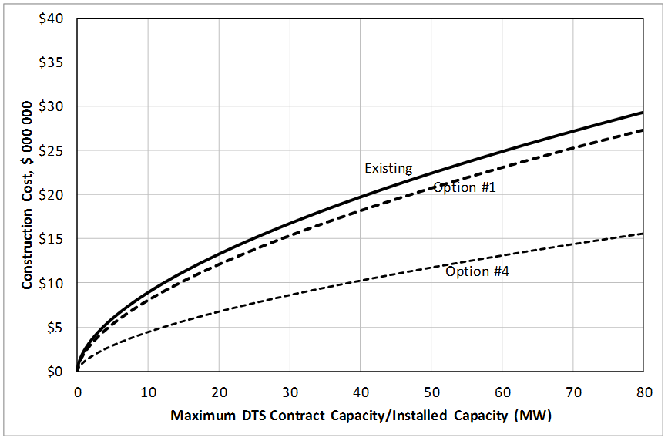
Stakeholder Comments:

- Comparison of options shape (Slide 41):

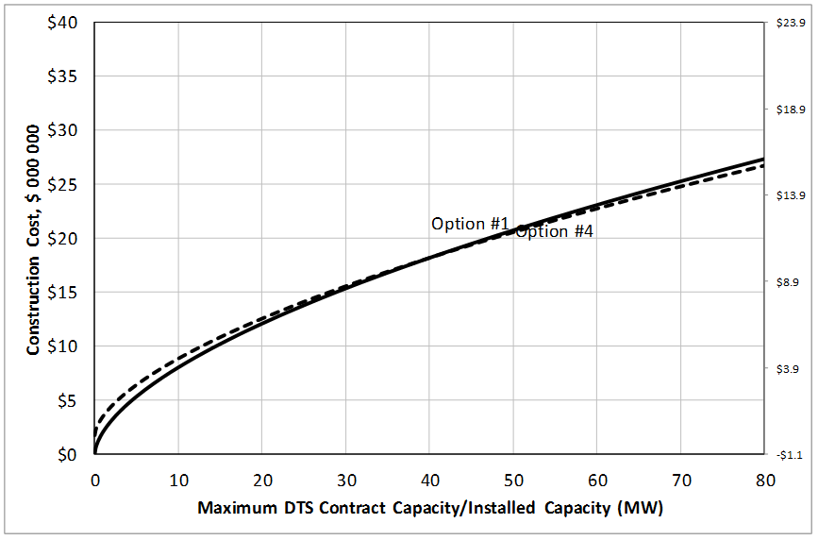
Stakeholder Comments:

- Translated installed capacity to contract capacity – X axis (Slide 42):
  - In order to continue to bill based on contract capacity, the cost curve x-axis for installed capacity must be “translated” to contract capacity;
  - In other words, create the exact same shape and dimensions as previous graph Option #4 which can be graphed against Option #1 without altering the secondary vertical axis.
Stakeholder Comments:

- Comparisons of options to existing (2014 ISO Tariff) cost function curve (Slide 43):

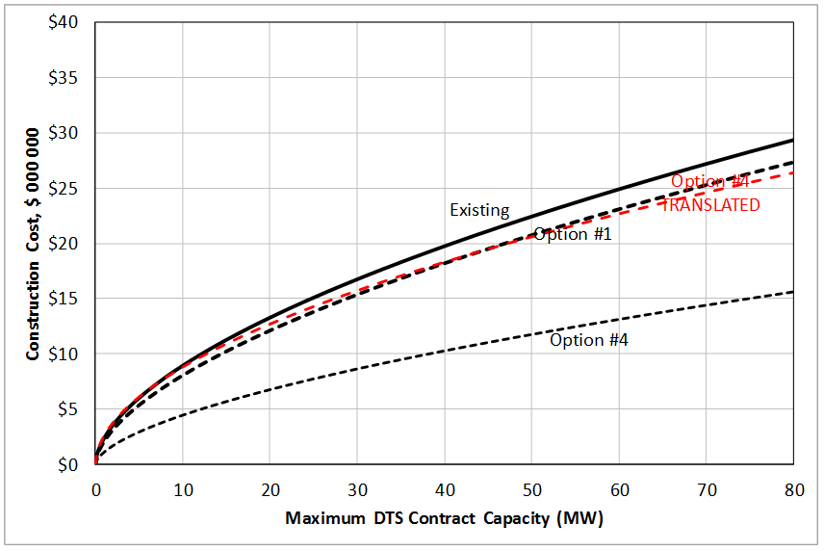

Stakeholder Comments:

- Criteria summary (Slide 44):

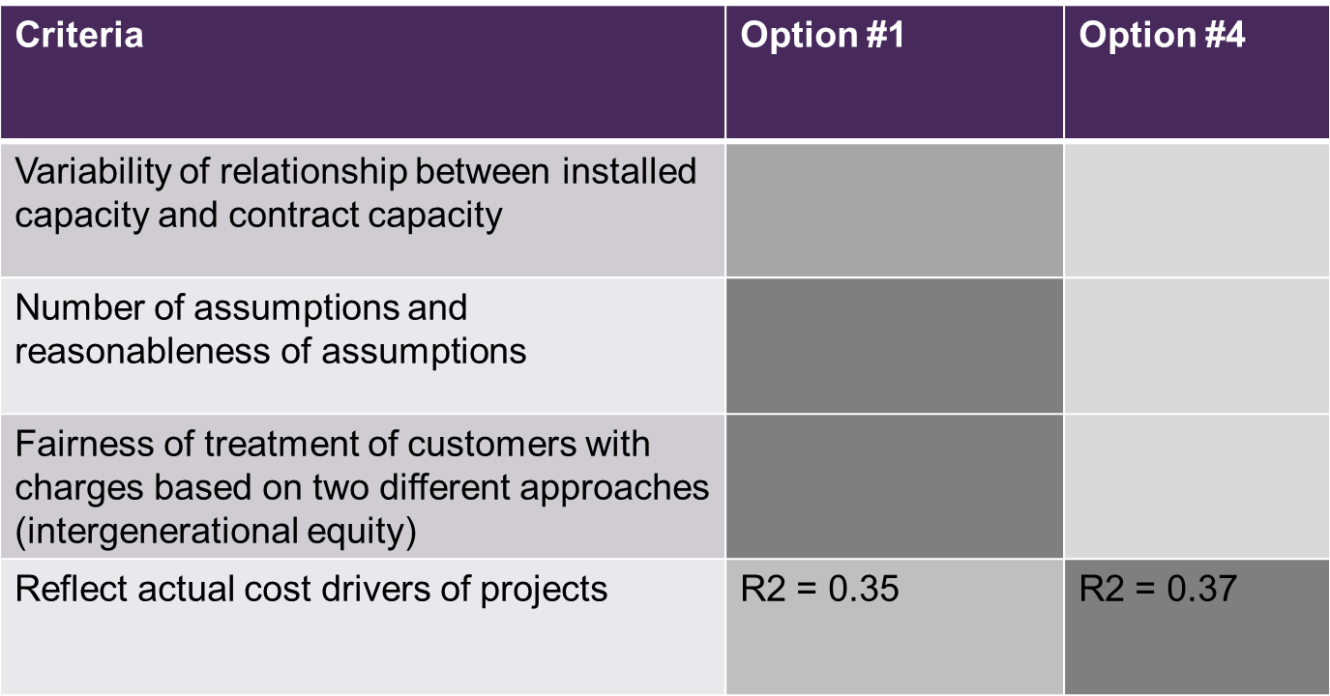
Stakeholder Comments:

- Impact on POD rates (Slide 45)

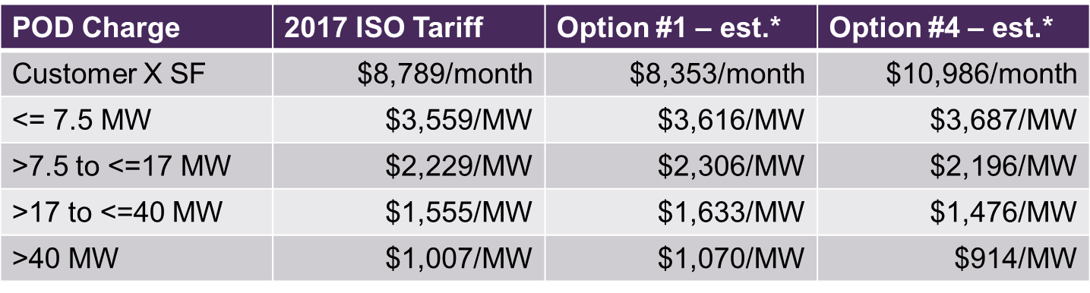

Stakeholder Comments:

- POD cost function – next steps (Slide 46):
- Proceed with rates calculations based on Option #1 – pre-2014 practice;
- Continue to work on translation of “Installed Capacity” cost curve to a “Contract Capacity” cost curve to provide analysis to Commission in application, in order to thoroughly explore the matter; and
- Application will include analysis of all four options.
Stakeholder Comments:

- Transmission Cost Causation Study Follow-up
(Slides 47 – 53)
- Preliminary 2018-2020 Functionalization (Slide 48):

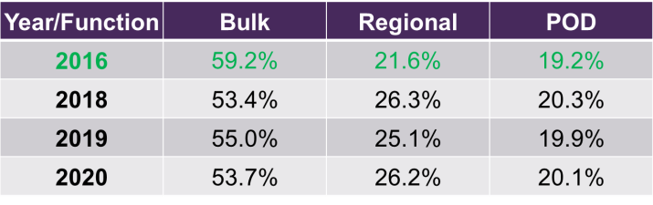
Stakeholder Comments:

- Regional system additions in 2020 (Slide 49):
- Downtown Calgary (P1456) – about $145 million
- Grande Prairie (P1784, P1785) – about $75 million
- Central East (PENV, P1781) – about $280 million, potentially moving to post-2020
Stakeholder Comments:

- Classification by minimum system approach (Slides 50-51):
- Demand related cost as ration of minimum system cost and optimal system cost (Slide 50)
  - 138kV: minimum system is 1x266 ACSR and optimal system is 1x477 ACSR
  - 240kV: minimum system is 2x795 ACSR and optimal system is 2x1033 ACSR
  - 500kV: minimum system is 2x2156 ACSR and optimal system is 3x1590
- Classification calculations (Slide 51):
  - Normalize cost to single circuit for 138kV;
  - Normalize cost to double circuit for 240kV; and
  - Escalate cost to common test year (new improvement for this study).
Stakeholder Comments:

- Regional system classification (Slide 52):

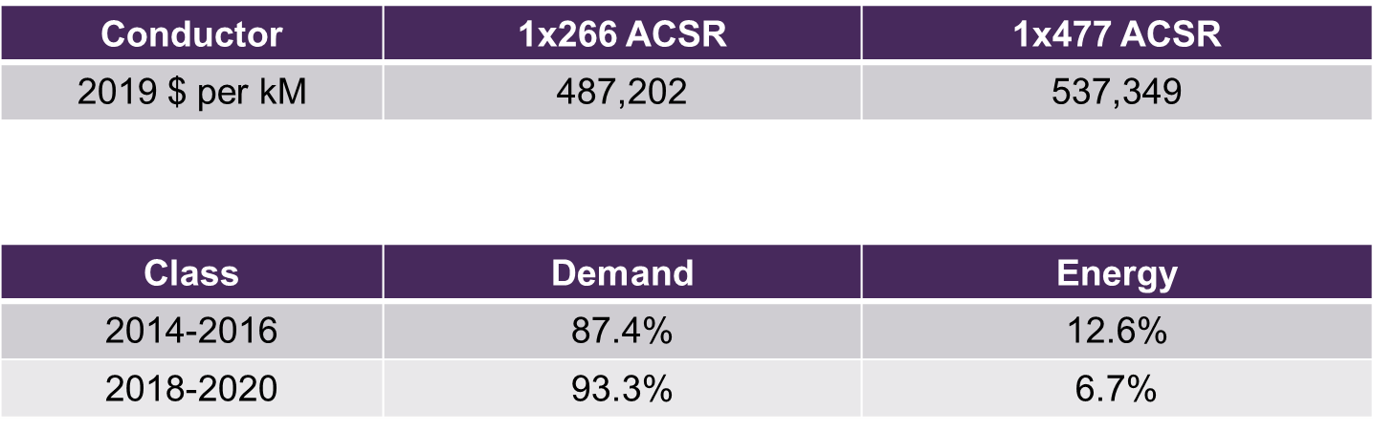
Stakeholder Comments:

- Bulk system classification (Slide 53):

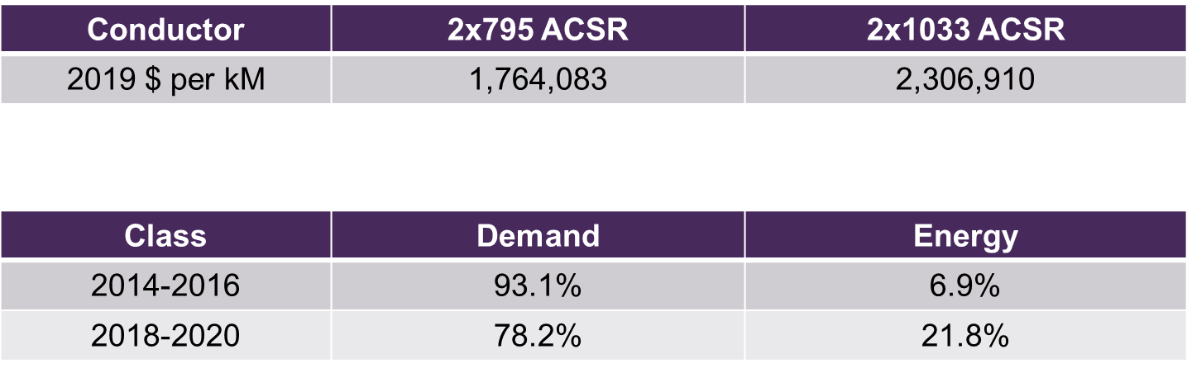
Stakeholder Comments:

- Critical Infrastructure Protections (“CIPs”) Cost Recovery (Slides 54-56)
- Background to CIPS Cost Recover Issue (Slide 55)
- Alberta reliability standard – Cyber Security – BES Cyber System Categorization CIP-002-AB-5.1 is planned to be effective on October 1, 2017
- TransAlta’s Sundance Facility (units 1-6) would be the only aggregated generating facility classified with a Medium Impact Rating subject to additional expenditures
- In Proceeding 3443, the Commission directed the AESO state if these costs would recoverable under the ISO tariff or not
Stakeholder Comments:

- AESO’s proposed position in upcoming application (Slide 56)
- Not recoverable under the tariff; generators should be individually responsible for the costs of complying with Alberta Reliability Standards, including CIPs
  - Based on AESO’s internal FEOC assessment (costs that are directly assigned to the market participant are more efficient that if they are socialized);
  - Consistent with the treatment of other Alberta reliability standards that provide a benefit to the AIES and all market participants.
- AESO’s rationale will be included in the ISO tariff application and may include evaluation of tariff, cost causation and FEOC principles.
Stakeholder Comments:

- Application Process, Timeline and Next Steps (Slides 57 – 62)
- The AESO discussed the status of a number of 2018 ISO tariff application scope items (Slide 36) and a 2018 ISO tariff tentative timeline.
Stakeholder Comments:

Additional Comments

Please return this form with your comments by May 2, 2017, to:
LaRhonda Papworth
Manager, Tariff Design
Email: larhonda.papworth@aeso.ca
Phone: (403) 539-2555

