Comment period: | Dec. 16, 2021 to Jan. 31, 2022 | Contact: | Company Representative
Comments from: | Company Name | Phone: | Contact Phone Number
Date: | [yyyy/mm/dd] | Email:

Instructions
- Please fill out the section above as indicated.
- Please respond to the questions below and provide your specific comments. We welcome your expertise and input and should some of the questions not be applicable to your area of expertise please feel free to leave those responses blank.
- Please submit one completed comment matrix per organization.
- Stakeholder comment matrices will be published on aeso.ca, in their original state.
- Email your completed comment matrix to forecast@aeso.ca by Jan. 31, 2022.

Introduction
Given the strong interest by stakeholders in potential pathways to a net-zero electricity grid by 2035, the AESO will be building upon the Clean-Tech Scenario of the 2021 Long-term Outlook (LTO) in an effort to provide further insights to our stakeholders. A driver for such analysis is that the potential transformation of the Alberta electricity system may occur at a faster pace and may involve technologies not considered in the 2021 LTO. Furthermore, this analysis will consider the technology review from the AESO 2021 Technology Forward Publication and the AESO Technology Summit 2021 – Power Tomorrow. The net-zero pathways analysis will inform and influence future long-term outlooks.
In 2022, the AESO will examine potential pathways to achieve a net-zero greenhouse gas emissions electricity sector in Alberta and the market, operational and cost implications of these pathways. The AESO intends to review and understand the most prominent zero and low-carbon emissions technologies, their cost and performance characteristics, and their impact to the grid, such that policy objectives may be achieved while minimizing disruptions to the existing market framework and maintaining a reliable electric system.
Alberta’s electricity generation fleet has undergone significant transformation. Formerly a greenhouse gas intensive, primarily coal-fired generation fleet, Alberta’s generation infrastructure has been converted and replaced with cleaner, less emissions intensive natural gas and renewable generation technology. Throughout this transformation, emissions have been reduced significantly, yet the AESO estimates that approximately 15Mt of emissions attributed to the electricity sector would need to be reduced by 2035 in order to achieve zero emissions. Placing a cost on carbon emissions via carbon taxes, and incentivization of clean generation via legislation and environmental and social governance practices have resulted in a significantly less carbon intensive electricity generation sector in Alberta. Further decarbonization ambitions have been announced by Canadian policymakers and industrial leaders intending to implement a net-zero emissions electricity generation target by 2035.
Electrification of high-emitting sectors and energy efficiency will also be key drivers along a pathway to net-zero outcomes. Mandates have been proposed for zero-emission vehicles, mentioned in the most recent federal election campaign and subsequent throne speech pledge, requiring at least half of all passenger vehicles sold in Canada be zero emission by 2030, reaching 100 percent in 2035. Support from various levels of government around energy efficiency from Emissions Reduction Alberta’s Energy Savings for Business to the federal Canada Greener Homes Grants are anticipated to continue to grow and support the electrification transition, which will drive additional emissions reductions economy wide.
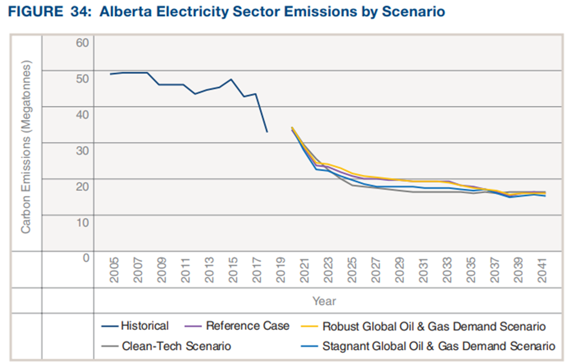

Request for feedback
The AESO is seeking feedback from interested stakeholders on their perspectives as it relates to the scope and input assumptions of the proposed net-zero emissions pathways analysis. Please be as specific as possible with your responses. Thank you.
Stakeholder engagement, dialogue, and feedback will be key to framing the AESO’s analysis and calibrating modeling parameters to ensure that the information provided to stakeholders via this analysis is valuable. The AESO would like to thank stakeholders in advance for their ideas, thoughts, and perspectives related to electric system decarbonization in Alberta.
 | Questions | Stakeholder Comments
1 | Net-Zero Analysis Scope  The AESO intends to produce the first AESO Net-Zero Emissions Electricity System Pathways report, to be published in June 2022. The AESO’s Pathways report will describe potential decarbonization pathways that can lead to a net-zero emissions electricity sector in Alberta by 2035. The report will include evaluation of supply-and-demand scenarios, which can result in decarbonization of the electricity system, and electrification of other emissions-intensive sectors. The initial report will review potential supply mix, market, supply adequacy and high-level cost implications. The report will not examine the full range of all potential operational impacts and related mitigation measures, the specific impact to consumers or provide quantitative analysis of all identified pathways. Subsequent analysis and reporting may focus on these more detailed metrics.  The AESO intends to review load and generation scenarios that reflect current trends in decarbonization, with the intention of illustrating possible pathways to net zero. With respect to supply the AESO intends to review two net-zero emissions generation supply scenarios in greater quantitative detail to gain further insight on potential market and operational implications. These are:  - Renewables paired with energy storage; and  - An economically driven generation resource addition scenario that considers a range of potential zero-emission sources, such as those technologies listed in section 6, below.  With respect to demand, the AESO intends to produce scenarios incorporating the impacts of significant electrification of transportation, buildings, and industrial activities, as well as the potential impact of demand-side management and energy efficiency initiatives.
 | - Is there any feedback that you would like to provide to the AESO with respect to the intended scenarios and analysis?
 | - What might be the largest challenges as well as the areas most impacted within the Alberta electric system on a path to net-zero?
2 | Macroeconomic Context  The current economic outlook shows Alberta growing at an average of nearly five per cent in the near-term and returning to a long-term trend of slightly over two per cent.  - What is your view on the economic impact of expected net-zero targets on this business-as-usual scenario?
The current IHS Markit outlook notes that Alberta oil sands production has surpassed pre-pandemic levels and forecasts incremental growth out to 2030 to more than 3.6 MMMb/d. Oilsands production is a key driver of Alberta’s load growth. In the 2021 LTO, the AESO adopted an earlier version of the IHS outlook as the base for the Reference Case; for the Clean-Tech scenario, the AESO de-rated the outlook by removing greenfield expansions to represent a scenario with no further sectoral growth (see chart below).

Figure X: Oilsands Outlook Assumptions in the 2021 LTO
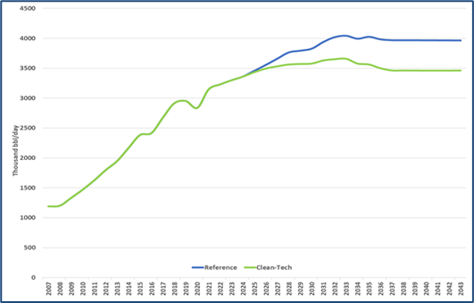
- What is your view on the AESO adopting a similar approach to that used to develop the 2021 LTO Clean-Tech scenario for analyzing the impact of net-zero policies on the oilsands sector and the subsequent impact on load growth?
 | - Current forward gas prices are in the $3/GJ range. Five years into the future, do you see gas prices remaining at this level, decreasing, or increasing beyond inflationary rates? What do you see as key drivers of gas prices going forward?
3 | Policy and Electricity Value Chain Impact  - Do you interpret net-zero emissions targets as enabling compliance via the following mechanisms?  - Offsets or credits (generated outside the electricity sector)  - Offsets or credits (generated within the electricity sector)  - Physical emissions reductions only
 | - What are your expectations of carbon prices in the future? With federally announced carbon prices rising from $50/t to $170/t by 2030, how do you see carbon price policy unfolding prior to 2030 and beyond 2030?
 | - What additional provincial or federal policies, policy scenarios or potential changes do you see impacting the Alberta electric system?
 | - Are there any other related considerations that you would like to provide feedback on?
4 | Electrification and Electricity Demand Drivers in Alberta  Energy efficiency  - What is your view on the potential penetration and pace of greater energy efficiency across sectors (residential, commercial, and/or industrial)? What would trigger more energy efficiency or conservation efforts?

Distributed Energy Resources (DER)
- How do you expect net-zero trends will impact DERs (e.g., gas-fired generation, solar, wind, small-scale energy storage systems, demand-side management technologies, load aggregator technologies, micro-grids, etc.)?

Transportation Sector
- What is your view on the potential penetration and pace of electrification of the transportation sector (e.g., passenger vehicles and light-duty trucks, commercial fleets, heavy-duty trucks, rail, other)?

Buildings
- What is your view on the potential penetration and pace of electrification of space heating/cooling and/or water heating?

Industrial Sectors
- Deployment of carbon capture, utilization and storage (CCUS) and hydrogen production (especially if based on electrolysis) could increase industrial load. What is your view on the expected increase in load (either served on-site or from the grid) from these industrial processes?
- What is your view on load growth and the impact of net-zero targets on other industries, sectors or technologies (e.g., cryptocurrency mining, data centers, petrochemical facilities, cement, steel, others)?
5 | Generation Technologies  - What net-zero enabling generation technologies do you perceive as being the most economic pathways to decarbonization of the electricity supply in Alberta?
- What are the strengths and weaknesses associated with the following net-zero enabling technologies, within the context of transitioning to net-zero emissions in Alberta’s electricity sector? What do you view as reasonable development timelines for these technologies?
- Post-combustion Carbon Capture, Utilization, and Storage
- Pre-combustion Carbon Capture, Utilization and Storage (hydrogen)
- Oxyfueled generation
- Renewable generation including wind, solar, geothermal, and biomass
- Hydroelectric generation
- Nuclear generation
- Energy Storage
- Transmission interconnections with other jurisdictions
- Offsets or Emissions Performance Credits
 | - Are there generation or emissions control technologies other than those listed in (b), which you believe can contribute to meaningful reductions in greenhouse gas emissions, and enable a pathway to net-zero emissions in Alberta?
 | - Do any of the net-zero enabling technologies in (b) or (c), above, impose operational risks, challenges or benefits to the electric systems in Alberta? If so, please identify.
 | - Do you expect the accounting of net-zero emissions by 2035 in the electricity sector to require net-zero emissions from cogeneration facilities? If so, what emissions control technologies do you believe can be most economically implemented at cogeneration facilities?
6 | Net-Zero Generation Technology Costs  The following table contains select net-zero enabling generation technologies and operational specifications on potential future generation developments. The data herein has been primarily derived from the US Energy Information Administration’s Capital Cost and Performance Characteristic Estimates for Utility Scale Electric Power Generating Technologies, then converted to Canadian dollars using an exchange rate of 1.26 CAD/USD. Hydrogen-fired combined cycle costs were derived from the cost estimates for publicly announced combined-cycle generation costs, assuming that the costs for hydrogen-capable generating stations will be similar to advanced combined-cycle plants.  Generation Type Plant Capacity, MW Capital Cost, $/kW Fixed O&M Costs, $/kW-yr Variable O&M Costs, $/MWh Heat Rate (HHV) or Efficiency, GJ/MWh or %  Fuel Cell 10 8,442 38.78 0.74 6.83 GJ/MWh  Advanced Nuclear Fission Reactor 2,156 7,612 153.27 2.99 11.19 GJ/MWh  Small Modular Reactor – Nuclear Fission 600 7,801 119.70 3.78 10.60 GJ/MWh  Hydroelectric 100 6,698 37.62 - -  Battery Energy Storage 50 (200MWh) 1,750 31.25 - 80% round trip efficiency  Wind Generation 200 1,594 33.19 - -  Solar Photovoltaic Generation 150 1,654 19.22 - -  Combined Cycle with CCUS 377 3,126 34.78 7.36 7.52  Hydrogen-Fired Combined Cycle 450 1,667 52.84 2.65 6.79
 | - Do you believe that these are representative of the costs associated with potential future Alberta net-zero generation technologies? How do you expect the cost of these technologies to change by 2035?
 | - What is your expectation of the retrofit costs to existing thermal generators to enable CCUS or hydrogen-fired generation?
 | - Please share any additional views on technologies and specifications that are not included within the table (please include the cost and operational characteristics applicable to the net-zero generation technology in the format of the provided table).
7 | Other  Please provide any additional information that you would like to share, which may contribute to the net-zero analysis development.
Thank you for your input. Please email your completed matrix to: forecast@aeso.ca

https://www.conferenceboard.ca/temp/dece8ebd-ff72-4d8d-9813-c85a9dd47c61/11357_ip_provincial-outlook_nov2021.pdf
https://ihsmarkit.com/research-analysis/canadian-oil-sands-running-above-prepandemic-highs.html
https://www.eia.gov/analysis/studies/powerplants/capitalcost/

